**Extended Abstract template for ICMRMEN 2025**

**Author1 Name a*, Author2 Nameb, Author3 Name a**

aDepartment of 1st& 3rd Author, Organization Name, City, State, Country

b Department of 2nd Author, Organization Name, City, State, Country

\**Corresponding author*: [sample_mail@mail.com](mailto:sample_mail@mail.com)

**Abstract**

This document is a template for the extended abstract (0 – 2 pages) for ICMRMEN 2025 using Microsoft Word. The styles and formats for ICMRMEN 2025 have been incorporated into the structure of this document. This opening abstract, limited to 100 words in Times New Roman,The authors are requested NOT to put page numbers as it would be numbered after compilation.

***Keywords***: Mention your keywords (maximum 5) in alphabetical order and separated with a semicolon (;)

# 1.0 Introduction

In this section, introduce the main problem and explain why your research matters. Offer some background to guide the reader, highlighting any gaps or unanswered questions. Keep it concise to show why your study is significant.Following this, the extended abstract may typically include sections on methodology, analysis, results and discussions, conclusions and references.

References are cited in the text by square brackets [1]. Two references should be cited as [2, 3] when used together and as [4-5] when more than two are cited together. The references are to be numbered in the order in which they are cited in the text and are to be listed at the end of the extended abstract. Limit the total citations to a maximum of 5 nos…..

# 2.0 Numerical/ Experimental procedure

The equations can be made using the equation editor or MathType. A displayed equation is numbered using right justified Arabic numbers in parenthesis as shown in equation (1). The equation is 10pt font centered, with 12pt spacing above and below the equation to separate it from the surrounding text.

${\left(1+x\right)}^{n}=1+\frac{nx}{1!}+\frac{n\left(n-1\right)x^{2}}{2!}$ $(1)$

Be sure that the symbols in your equation have been defined before or immediately following the equation.

Figures, referenced in text sequentially as Fig. 1, Fig. 2… in the order of appearance should seamlessly integrate into the text, providing enough space to distinguish them from the surrounding content. Each ………A sample is shown below.

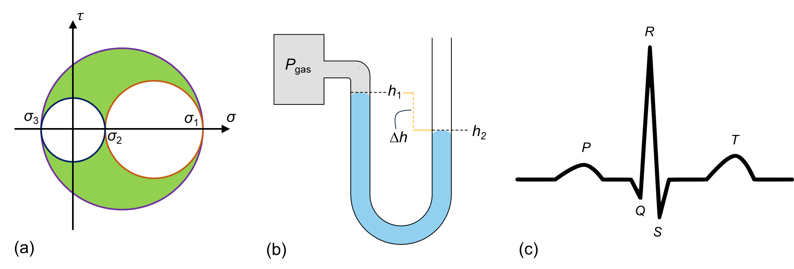

Fig. 1 Sample figures for (a) Mohr’s circle for a 3-D stress state, (b) U-tube manometer and (c) an electrocardiogram waveform

# 3.0 Results and conclusions

A sample table for illustration is provided below.

Table 1 Sample table for experimental evaluation of axial stiffness

|  |  |  |  |
| --- | --- | --- | --- |
| Experiment | Force Applied (N) | Displacement (mm) | Stiffness (N/mm) |
| Test 1  Test 2  Test 3 | 100 | 5.25 | 19.23 |
| 150 | 7.45 | 20.13 |
| 120 | 6.05 | 19.83 |

All experimental results must be assessed and validated by statistical parameters for acceptance with error bands and uncertainties reported……..

# 4.0 References

1. Author(s) name,Year, "*Book Title*," Publisher.
2. Author(s) name, Year,"*Article Title*," Journal Name, vol., issue, pp.,year, doi
3. Author(s) name, Year,"*Paper Title*," in Proc. Conference Name (*Conference Acronym Year*), pp.,.
4. Author(s) name,Year, "*YouTube Lecture Series Title*," URL (accessed Month Day, ).
5. "*Webpage Title*,Year," URL (accessed Month Day,).